Card game “BlackJack”

Octavian Almurzin
School of Artificial Intelligence and Data Science, Astana IT University
Major - Mathematical and Computational Science
Group - 2503
February 6, 2026

Subject Area Description
Blackjack, also known as Twenty-One, is a comparing card game played between a dealer and one or more players. In this game, each player competes individually against the dealer. The primary objective is to beat the dealer's hand by achieving one of three outcomes: obtaining a total of 21 points on the first two cards (a "blackjack" or "natural") without the dealer doing the same; reaching a final score higher than the dealer’s without exceeding 21; or allowing the dealer to draw additional cards until their hand exceeds 21, resulting in a "bust."

Core Entities
The domain model captures the essential components required to represent the physical game, beginning with the Card, which is the fundamental unit. A card’s behavior is immutable, and its key responsibility is to provide specific data regarding its Rank and its Suit. These cards are organized into a Deck, a collection used to facilitate gameplay. A standard deck contains 52 cards, consisting of 13 ranks across four suits. The deck is subject to specific constraints, such as becoming empty, which necessitates operations like shuffling to randomize the order for fairness or dealing to distribute cards to participants.
The Hand represents the collection of cards currently held by a specific participant. Its responsibilities include storing the list of dealt cards and performing complex score calculations that account for the dynamic value of Aces, which can be valued at 1 or 11. The hand is also responsible for the "bust check," determining if the total point value exceeds 21. Finally, the Player is an abstract participant in the game, defined by attributes such as a name, the current hand, and win/loss statistics. Players are categorized as either Human Players, who make decisions like "Hit" or "Stand" based on user input, or AI Players (the Dealer), who make decisions based on a fixed strategy or algorithm.

Game Mechanics and Rules
The game operates on a distinct value system where number cards (2–10) are worth their face value, face cards (J, Q, K) are worth 10 points each, and Aces are worth 1 or 11 points depending on which value prevents the hand from busting. A hand containing an Ace counted as 11 is referred to as "soft," whereas a hand without an Ace or with an Ace counted as 1 is considered "hard."
The game flow begins with an initial deal in which both the player and the dealer receive two cards; typically, one of the dealer's cards remains hidden as the "hole card." During the player's turn, they may choose to "Hit" to take another card or "Stand" to keep their current total. If the player’s total exceeds 21, they bust and lose immediately. Once the player concludes their turn, the dealer reveals their hidden card. The dealer is required to hit until their total reaches 16 or higher. If the dealer exceeds 21, they bust, and any remaining players win. In the final showdown, if neither party busts, the higher score wins, while equal scores result in a "Push" or tie.

Project Goals and Objectives
The primary goal of this project is to design and implement a robust, console-based simulation of the Blackjack card game using the Java programming language. This application distinguishes itself through a strict adherence to Object-Oriented Programming (OOP) principles and industry-standard design patterns. Educationally, the project serves as a practical application of advanced software engineering concepts, specifically the application of SOLID principles. Furthermore, the implementation effectively utilizes the Repository Pattern for data abstraction and the Strategy Pattern for interchangeable game logic, such as AI behavior, while constructing a clean separation of concerns by organizing code into distinct Domain, Repository, Service, and Application layers.
Functionally, the application must verify several core capabilities, starting with the accurate simulation of a Blackjack round, including shuffling, dealing, and turn-based play. It must support standard player decisions, such as "Hit" to draw a card or "Stand" to end a turn, alongside an automated dealer that follows strict casino rules, such as hitting on a soft 16, via a dedicated strategy. The system is required to correctly calculate hand values by handling special cases like Aces, which may be valued at 1 or 11, and determining "Busts" when totals exceed 21. Additionally, the application must accurately compare player and dealer hands to declare winners, losers, or ties (Push), while maintaining a persistent in-memory record of player statistics throughout the application runtime.
Technical constraints and objectives mandate the use of Java as the primary language due to its strongly typed, object-oriented nature. Storage is strictly limited to in-memory RAM using standard Java Collections like List, Map, and Set, with no reliance on external databases or file I/O for data persistence. The interface is restricted to a purely console-based Command Line Interface (CLI) without a Graphical User Interface (GUI). Regarding code quality, the project requires the avoidance of static context abuse by placing business logic in instances, the implementation of proper exception handling through custom exceptions, and the enforcement of encapsulation via private fields and public accessors.

Project Architecture
The application adheres to a Layered Architecture, a strategic design choice that promotes the separation of concerns and enhances maintainability by ensuring each layer possesses a specific responsibility and interacts with others through well-defined interfaces. The architecture is orchestrated by the App Layer, which serves as the entry point. Specifically, the Main.java component within this layer initializes dependencies - such as the Repository, Service, and Players - starts the game loop, and manages user input and output for the console interface. To function, the App Layer depends on all other layers to fully assemble the application.
The core business logic and game flow are managed by the Service Layer. The GameService.java component controls the game state, including the deck, players, and turns, while strictly enforcing Blackjack rules such as dealing cards, calculating scores, handling busts, and determining winners. This layer relies on the Domain layer to manipulate game entities and the Repository layer to persist player statistics. Data persistence is abstracted by the Repository Layer, which defines a PlayerRepository interface for saving and retrieving player data. A concrete InMemoryPlayerRepository implementation stores this data in a HashMap, ensuring that the underlying storage mechanism remains decoupled from the business logic.
The Strategy Layer encapsulates interchangeable algorithms, specifically AI logic, through the PlayStrategy interface. Implementations such as DealerStrategy, which follows standard casino rules, and RiskyStrategy allow for dynamic decision-making based on Hand and Card data. At the foundation lies the Domain Layer, representing core business objects including Card, Deck, Hand, and Player (both Human and AI). Ideally, this layer remains pure Java with no outward dependencies. The architecture effectively integrates key design patterns: the Repository Pattern decouples storage implementation from business logic, allowing for storage flexibility, while the Strategy Pattern enables AIPlayer instances to switch playstyles dynamically at runtime without altering the core codebase.

UML diagram
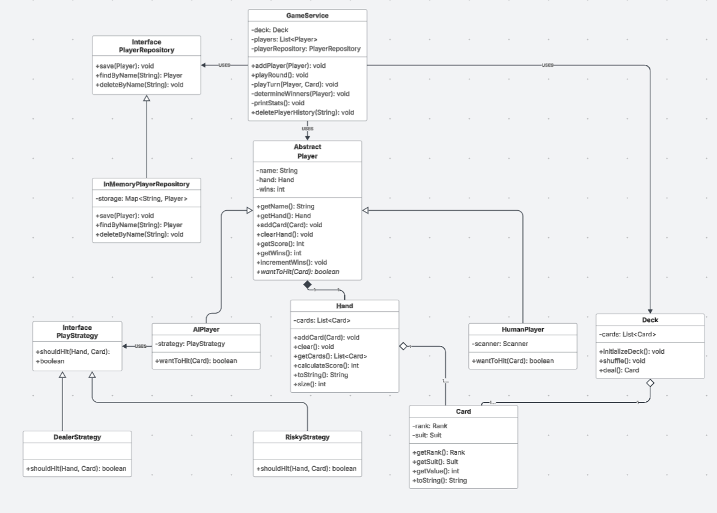
link - Lucidchart document

Class Description
The application is organized into distinct packages that separate concerns according to the project's architecture. The domain package contains the core business entities of the game. Central to this package is the Card class, which represents a standard playing card defined by a specific Rank (e.g., King, Ace) and Suit (e.g., Hearts, Spades). It includes a getValue() method that returns the numeric value of the card, with face cards defaulting to 10 and Aces to 11. The Deck class represents a standard 52-card collection and is responsible for initializing unique cards, randomizing their order via the shuffle() method, and removing the top card using the deal() method, which throws a DeckEmptyException if no cards remain.
The Hand class manages the collection of cards held by a specific player. Its primary responsibilities include adding cards to the hand and employing dynamic logic within the calculateScore() method to compute the total value, automatically adjusting Aces from 11 to 1 if the score exceeds 21. The Player abstract class serves as the base for all game participants, maintaining fields for the player's name, current hand, and win statistics. It defines the abstract method wantToHit(), which forces subclasses to specify turn behavior, and includes incrementWins() to update records. This class is extended by two concrete implementations: HumanPlayer, which prompts the user for input via the console, and AIPlayer, which delegates decision-making to a PlayStrategy object, effectively utilizing the Strategy Pattern.
Data persistence is handled by the repository package. The PlayerRepository interface defines the contract for saving and retrieving player data through methods such as save() and findByName(). This interface is implemented by the InMemoryPlayerRepository, a concrete class that utilizes a HashMap for RAM-based storage, meaning data persists only while the application is running.
The business logic and game flow are centralized in the service package within the GameService class. Acting as the controller, this class manages the game loop, enforces rules such as dealing cards and checking for busts, manages turns for all participants, and determines winners while updating statistics in the repository.
AI behaviors are defined in the strategy package. The PlayStrategy interface establishes the behavioral contract for specific game strategies through the shouldHit() method. This is implemented by the DealerStrategy, which adheres to standard casino rules by hitting on scores below 16 and standing on 16 or higher, and the RiskyStrategy, which adopts a more aggressive approach by hitting on scores below 18. Finally, the app package serves as the entry point for the application. The Main class bootstraps the system by instantiating the repository, service, and players, managing the high-level "Play Again?" loop, and handling global exceptions.

Used Design Patterns
This project explicitly implements two key GoF design patterns to ensure decoupling, flexibility, and maintainability. The first is the Repository Pattern, a structural pattern used to mediate between the domain and data mapping layers. Its primary intent is to isolate domain objects from the details of the database access code by using a collection-like interface. In the project case the PlayerRepository interface defines the contract for data operations, such as saving and finding players by name, without specifying the underlying storage mechanism. The concrete implementation, InMemoryPlayerRepository, fulfills this contract using a HashMap. This design ensures that the GameService depends solely on the abstraction, adhering to the Dependency Inversion Principle (DIP). Consequently, the underlying storage could be switched to a SQL database or file system without requiring changes to the business logic.
The second pattern employed is the Strategy Pattern, a behavioral pattern intended to define a family of algorithms, encapsulate each one, and make them interchangeable. This allows the algorithm to vary independently from the clients that use it. Within the project, the AIPlayer class requires decision-making logic but is designed to avoid hardcoding a single style of play. The PlayStrategy interface defines the common behavior through the shouldHit method, which accepts a hand and the dealer's visible card. Concrete strategies, such as DealerStrategy (which hits on soft 16) and RiskyStrategy (which plays more aggressively), implement this interface. This approach allows the difficulty or behavior of the AI player to be changed at runtime by simply passing a different strategy object. Furthermore, it adheres to the Open/Closed Principle (OCP), enabling the addition of new strategies, such as a card-counting algorithm, without modifying the existing AIPlayer class.

Implementation of SOLID
The Single Responsibility Principle posits that a class should possess only one reason to change, effectively strictly limiting its functionality to a specific domain. In the current Blackjack project, this principle is effectively demonstrated through the implementation of domain entities such as the Card, Deck, and Hand classes. Specifically, the Card class is restricted to holding card data, the Deck class manages the shuffling and dealing operations, and the Hand class is solely responsible for score calculations. Furthermore, the application of the Strategy pattern within the AIPlayer class ensures that decision-making logic is delegated to PlayStrategy, thereby maintaining a clean separation between AI logic and player state management. However, a potential area for improvement exists regarding the coupling of the User Interface (UI). Currently, the HumanPlayer class interacts directly with Scanner, and the GameService relies on System.out.println. To facilitate a seamless transition to a Graphical User Interface (GUI) or web interface in the future, it would be advisable to extract a GameView interface, which would decouple input and output mechanisms from the core game rules.
According to the Open/Closed Principle, software entities should be open for extension but closed for modification. This project exhibits a strong adherence to this principle, particularly through the utilization of the Strategy pattern in the strategy package. New strategies, such as a hypothetical CardCountingStrategy, can be introduced by creating new classes that implement the PlayStrategy interface without requiring alterations to the AIPlayer class or existing source code. Additionally, the player hierarchy supports this principle; the GameService operates on the abstract Player class, allowing for the integration of new player types without necessitating changes to the primary game loop.
The Liskov Substitution Principle mandates that subtypes must be substitutable for their base types without altering the correctness of the program. The project satisfies this requirement through the HumanPlayer and AIPlayer classes, which correctly extend the Player abstract class. The GameService interacts with these subclasses uniformly, for instance, by invoking player.wantToHit(), without relying on type checks such as instanceof. Consequently, both subclasses honor the contract defined by the Player class, ensuring that the system remains robust and predictable regardless of the specific player type in use.
The Interface Segregation Principle states that clients should not be forced to depend on interfaces they do not use. The project adheres to this by designing focused, minimal interfaces. The PlayerRepository interface is strictly limited to persistence operations, such as saving, finding, and deleting records, thereby avoiding the imposition of unrelated methods on its implementations. Similarly, the PlayStrategy interface contains a single method, shouldHit. This targeted approach simplifies implementation and ensures that classes are not burdened with unnecessary dependencies.
Finally, the Dependency Inversion Principle requires that high-level modules depend on abstractions rather than low-level modules. The Blackjack application demonstrates this through the use of the Repository pattern. The GameService, representing high-level logic, depends on the PlayerRepository interface rather than the low-level InMemoryPlayerRepository implementation. This architectural decision allows for the underlying storage mechanism to be swapped, for example, migrating to a database, without modifying the service logic. Furthermore, the use of constructor injection in GameService promotes loose coupling and enhances the testability of the system.

Demo Scenario
Scene | User Action / Input | Expected System Behavior / Output
1. Game Start | Launch App  Input: Alice | System: "Welcome to Blackjack!"  Output:  --- New Round ---  Alice's turn.  Hand: [7♥, 5♣] (Score: 12)  Dealer shows: K♠
2. The "Hit" | Input: H (or Hit) | Action: A new card is dealt from the deck.  Output:  Alice hits and gets 4♦.  Score: 16
3. The "Stand" | Input: S (or Stand) | Action: Turn passes to Dealer.  Output:  Alice stands.  Dealer reveals: [K♠, 6♥] (Score: 16)  Dealer hits... gets 2♣ (Score: 18)  Dealer stands.
4. Showdown | (None) | Action: Scores are compared.  Output:  --- Results ---  `Dealer: 18
5. Persistence | Input: Y (Play Again)  (Complete Round 2) | Output (End of Round 2):  --- Current Stats ---  Alice Wins: 0  Dealer Wins: 1  (Must show cumulative total)
6. The "Bust" | Input: H  (Repeat until score > 21) | Output:  Alice hits... Score: 24  Alice busted!  --- Results ---  Alice loses.

Conclusion
To conclude, the Blackjack simulation project has successfully demonstrated the practical application of advanced Object-Oriented Programming principles and software engineering best practices. By adhering to a Layered Architecture, the application achieved a clean separation of concerns, ensuring that business logic, data persistence, and user interaction remain distinct and manageable. The implementation of the Repository and Strategy design patterns fulfilled the functional requirements, such as dynamic AI behavior and interchangeable data storage, and reinforced the system's compliance with SOLID principles, particularly the Open/Closed and Dependency Inversion principles.

